- Siming District · Yundang Lake Xidi Tidal Sluice
Yundang Lake lies in southwestern Xiamen Island. It was once Yundang Harbour, connected to the western sea, before the construction of the Xidi embankment enclosed it as a lake. The tidal sluice was built in 1988 to improve water quality by increasing exchange with the sea. Before the sluice opens, flocks of egrets wait on perches in the lake. When seawater flows in, it carries fish into the lake, drawing egrets to hover and dive for them above the sluice. From Tidal Square or the birdwatching walkway, visitors can enjoy this lively scene without disturbing the birds.
Getting there: Navigate to ‘Yundang Lake Tidal Square’ or ‘Yundang Lake Birdwatching Walkway’. Take a bus to the Haiwan Park bus stop, or take Metro Line 2 to Jianye Road Station; then walk to the sluice. Drivers can use the Haiwan Park car park or legal parking spaces along Yundang Road. Spaces are limited, so public transport is recommended.
Suggested birding duration: About 2–3 hours; arrive before the sluice opens.
Best months: April to early November.
Difficulty: ★☆☆☆☆ (1/5) Public transport is convenient, walking around Tidal Square and the birdwatching walkway is easy, and supplies are available nearby.
Common residents: Little Egret, Black-crowned Night Heron, Chinese Pond Heron, etc.
Common winter visitors: Great Egret, etc.
Birding tip: Check the ‘Jinming Napai’ (today's and tomorrow's sluice schedule) section of the ‘Yundang Lake’ WeChat account for daily opening times. Around the first and fifteenth days of the lunar month, spring tides produce a larger tidal range and bring more fish and shrimp into the lake. Keep quiet and do not feed or chase the birds.

Point to mark on the birding map: One marker at the Xidi embankment is sufficient.

- Siming District · Dongping Mountain Park
Dongping Mountain Park lies in the Hongji Mountain area of southern Xiamen Island. It covers approximately 4.5 square kilometres and retains a variety of mountain habitats, including woodland, a reservoir and grassland. Dongshan Reservoir and its surrounding woods attract forest birds during migration; Japanese Paradise Flycatcher, Black-winged Cuckooshrike and Hair-crested Drongo have been recorded here. The open views at Guishi Wangding make it a good place to watch migrating raptors and swifts in spring and autumn. In summer, look for Blue-tailed Bee-eater, Chestnut-winged Cuckoo and Oriental Dollarbird.

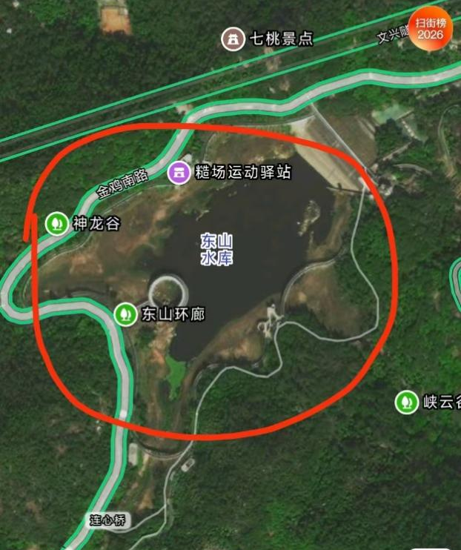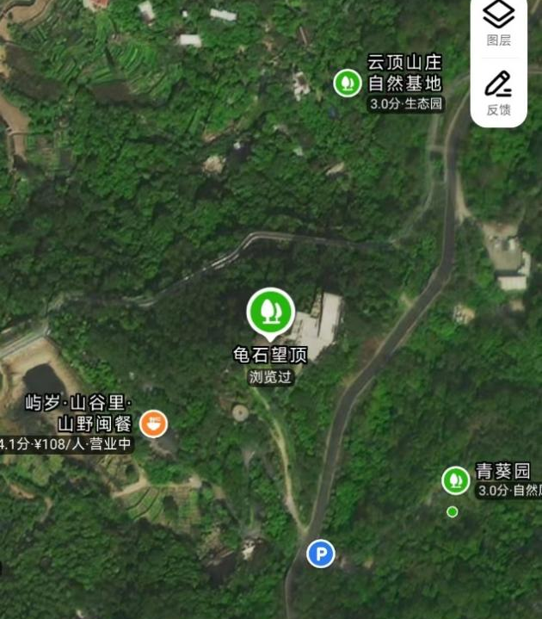

Getting there: Navigate to ‘Dongshan Reservoir’ or ‘Guishi Wangding Viewing Platform’. The Dongping Mountain shuttle bus serves the Dongshan Reservoir and Dongping Shan She bus stops; get off at the stop for your chosen area. Driving or taking a taxi is also possible. Parking on the mountain is limited; set off early on weekends and public holidays.
Suggested birding duration: About 2–4 hours.
Best months: March–May and September–November for migrants; summer for Blue-tailed Bee-eater, Chestnut-winged Cuckoo and Oriental Dollarbird.
Difficulty: ★★☆☆☆ (2/5) The path around Dongshan Reservoir is fairly level, but the route to Guishi Wangding has a sustained climb and some steps. Most places to buy supplies are in the hillside communities; bring plenty of water and insect repellent in summer.
Common residents: Greater Necklaced Laughingthrush, Common Kingfisher, Little Egret, Light-vented Bulbul, Chinese Bamboo Partridge, etc.
Common passage migrants: Chinese Sparrowhawk, Grey-faced Buzzard, Japanese Sparrowhawk, Amur Falcon, Crested Honey-buzzard, Eurasian Hobby, etc. Migrant records also include Pacific Swift, White-throated Needletail, Japanese Paradise Flycatcher, Black-winged Cuckooshrike, Siberian Rubythroat, Black-naped Monarch, etc.
Summer visitors: Blue-tailed Bee-eater, Chestnut-winged Cuckoo, Oriental Dollarbird, etc.
Winter visitors: Red-flanked Bluetail, Daurian Redstart, Great Egret, etc.

Notable records: Purple Needletail and Silver-backed Needletail.

Points to mark on the birding map: Dongshan Reservoir and Guishi Wangding.

- Huli District · Wutong Pukou
Pukou, a coastal neighbourhood in eastern Huli District on Xiamen Island, was once a shallow coastal depression. The surrounding mudflats, beach, ponds and open ground offer a range of habitats. Shorebirds feed and rest on the mudflats and beach, while the ponds and rough ground attract White-throated Kingfishers, Blue-tailed Bee-eaters and cuckoos. The changing mix of visitors in spring and autumn makes this a rewarding place to discover unexpected birds.
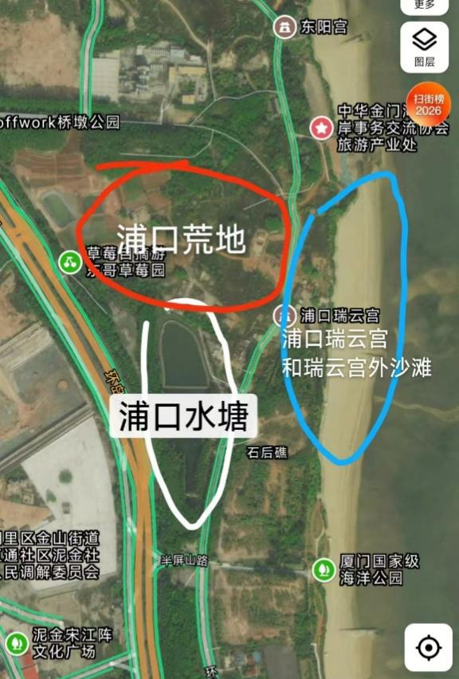
Getting there: Navigate to ‘Pukou Ruiyun Temple’. Driving or taking a taxi is recommended. For metro travel, get off at Cross-Strait Financial Center Station on Line 2 and follow a map app to walk from the metro station to Pukou.
Suggested birding duration: About 2–3 hours. Check the tide before visiting. Around high tide, scan the beach for resting birds. As the mudflats emerge on the falling tide, shorebirds gradually return to feed. The timing depends on the day's tide levels.
Best months: March–May and July–December. Look for passage shorebirds and forest birds in spring and autumn. From July onward, Blue-tailed Bee-eaters may arrive with their young to feed after breeding.
Difficulty: ★★☆☆☆ (2/5) Existing paths provide access to viewpoints by the beach and rough ground, though some surfaces are uneven. There are few places to buy supplies by the beach; bring water.
Common residents: Little Egret, Plain Prinia, Black-winged Kite, Pied Kingfisher, Greater Coucal, etc.
Common passage migrants: Edible-nest Swiftlet, Greater Sand Plover, Pacific Golden Plover, Grey-tailed Tattler, Grey-streaked Flycatcher, Yellow-rumped Flycatcher, Asian Brown Flycatcher, etc.
Summer visitors: Blue-tailed Bee-eater, White-faced Plover, Little Tern, Black Drongo, Plaintive Cuckoo, etc.
Winter visitors: Great Cormorant, various shorebirds, etc.
Notable records: Malayan Night Heron, Red-breasted Flycatcher, Yellow Bunting, Relict Gull, Thick-billed Warbler, Lesser Frigatebird, Brown Booby, Pallas's Gull, etc.
Birding tip: Scan the sea and tideline from shore, then check the ponds, grass and shrubs in open areas. Keep your distance from resting birds. Do not enter fenced areas or walk onto the mudflats to pursue birds.

Points to mark on the birding map: 1. Pukou Ruiyun Temple (the shoreline is the waterbird viewing area); 2. Pukou ponds (waterbirds and forest birds often gather nearby); 3. Pukou open ground (Blue-tailed Bee-eaters often feed here in summer).

- Huli District · Hutoushan Park
Hutoushan Park lies east of Jinshang Road in Huli District on Xiamen Island and covers approximately 140,000 square metres. Its trees and shrubs provide resting and feeding habitat for migrating forest birds. During spring and autumn migration, walk slowly along the wooded paths and watch the canopy, forest edges and undergrowth for passing warblers, flycatchers and other migrants. In winter, look for thrushes.
Getting there: Navigate to ‘Hutoushan Park’ (No. 1042 Jinshang Road, Huli District). Alternatively, take a bus to one of these bus stops: Taiwei Shanzhuang, Di'er Fuli Yuan or Jinshan Xiaoxue. Then walk to the park. Parking in and around the park is limited; public transport or a taxi is recommended.
Suggested birding duration: About 2 hours; allow half a day during migration.
Best months: March–May and September–December.
Difficulty: ★☆☆☆☆ (1/5)
The park is accessible by bus. The hillside paths include slopes and steps; bring drinking water.

Common residents: Light-vented Bulbul, Red-billed Blue Magpie, Masked Laughingthrush, etc.
Common passage migrants: Amur Paradise Flycatcher, Japanese Paradise Flycatcher, Asian Brown Flycatcher, Grey-streaked Flycatcher, Narcissus Flycatcher, Blue-and-white Flycatcher, Arctic Warbler, Pale-legged Leaf Warbler, etc.
Summer visitors: Plaintive Cuckoo and Asian Koel.
Winter visitors: Pale Thrush, Grey-backed Thrush, etc.
Notable records: Ryukyu Flycatcher, Brown-chested Jungle Flycatcher, Fairy Pitta, Malayan Night Heron, Japanese Scops Owl, Japanese Robin, etc.
Birding tip: Passage migrants may stay only briefly, so sightings can change from day to day. In the early morning, slow down, listen for calls and song, and then search among the leaves.

- Haicang District · Tianzhu Mountain Forest Park
Tianzhu Mountain Forest Park lies in northwestern Haicang District. It covers approximately 26.51 square kilometres, reaches an elevation of 933 metres, and has forest cover exceeding 98%. Its reservoirs include Tianzhu Lake, Haoyue Lake and Lianger Lake. With more than 200 recorded bird species, it is Xiamen's most diverse area for forest birds. Residents include Silver Pheasant, White-necklaced Partridge, Common Emerald Dove, Slaty-backed Forktail, Grey-sided Scimitar Babbler, Grey Treepie, Red-billed Leiothrix and Mountain Tailorbird. The calls of Lesser Shortwing, Spotted Elachura, Pygmy Cupwing and Great Barbet also echo through the valleys. Summer visitors include Square-tailed Drongo-Cuckoo, Asian Lesser Cuckoo, Hodgson's Hawk-Cuckoo and Chestnut-winged Cuckoo, as well as Hainan Blue Flycatcher, Orange-headed Thrush and Brown-breasted Flycatcher. Passage migrants recorded here in spring and autumn include Green-backed Flycatcher, Japanese Robin, Siberian Rubythroat, Ryukyu Flycatcher, etc. In winter, look for flycatchers such as Verditer Flycatcher and Mugimaki Flycatcher, and thrushes such as Japanese Thrush and Pale Thrush.

Birding routes:
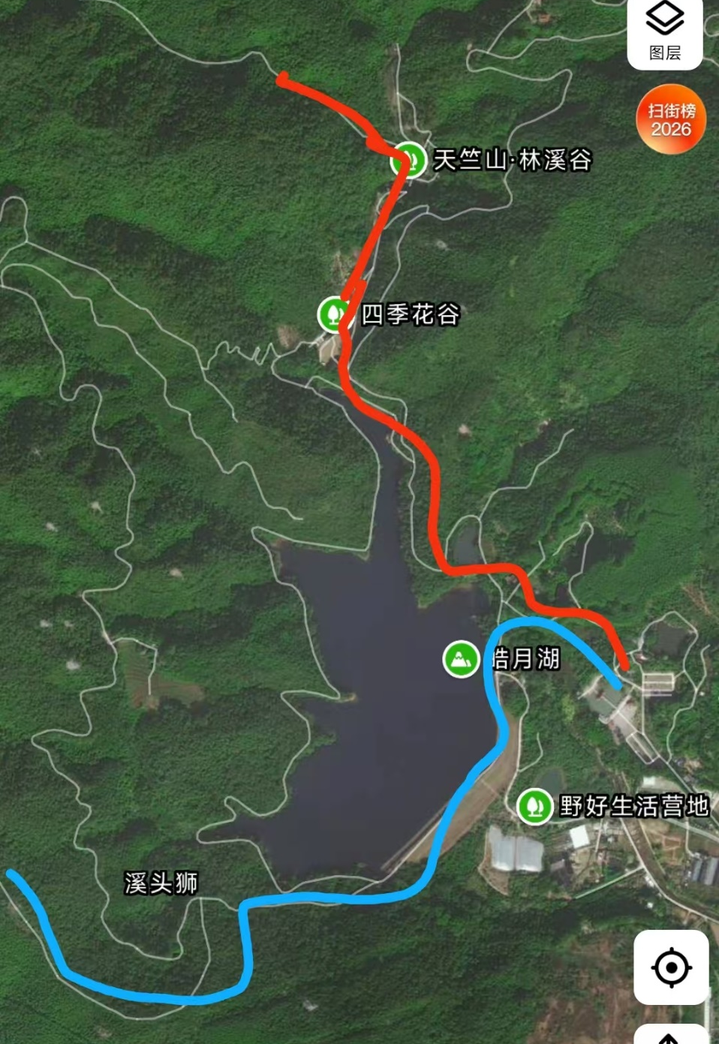
Red indicates West Gate Route 1; blue indicates West Gate Route 2.
West Gate Route 1 | West Gate — Four Seasons Flower Valley — Zhonghailin — Grand Canyon: Enter through the West Gate and follow the stream through Four Seasons Flower Valley towards Zhonghailin. Follow the park signs to the Grand Canyon entrance. On the canyon trail, pass a public toilet and continue to a metal-clad water tank. Stone-paved paths and steps alternate along the route. Slow down and search carefully within roughly 200 metres of the toilet. This route is popular, so arrive early in the morning. Refreshments are available near the entrance to Four Seasons Flower Valley. Allow 2–4 hours.
West Gate Route 2 | West Gate — Haoyue Lake — Xitoushi: From the West Gate, follow Haoyue Lake towards Xitoushi. The route is long but generally level and has fewer visitors. Supplies are scarce along the way. Bird activity varies with the movement of flocks; allow at least 2–4 hours and bring water and food.

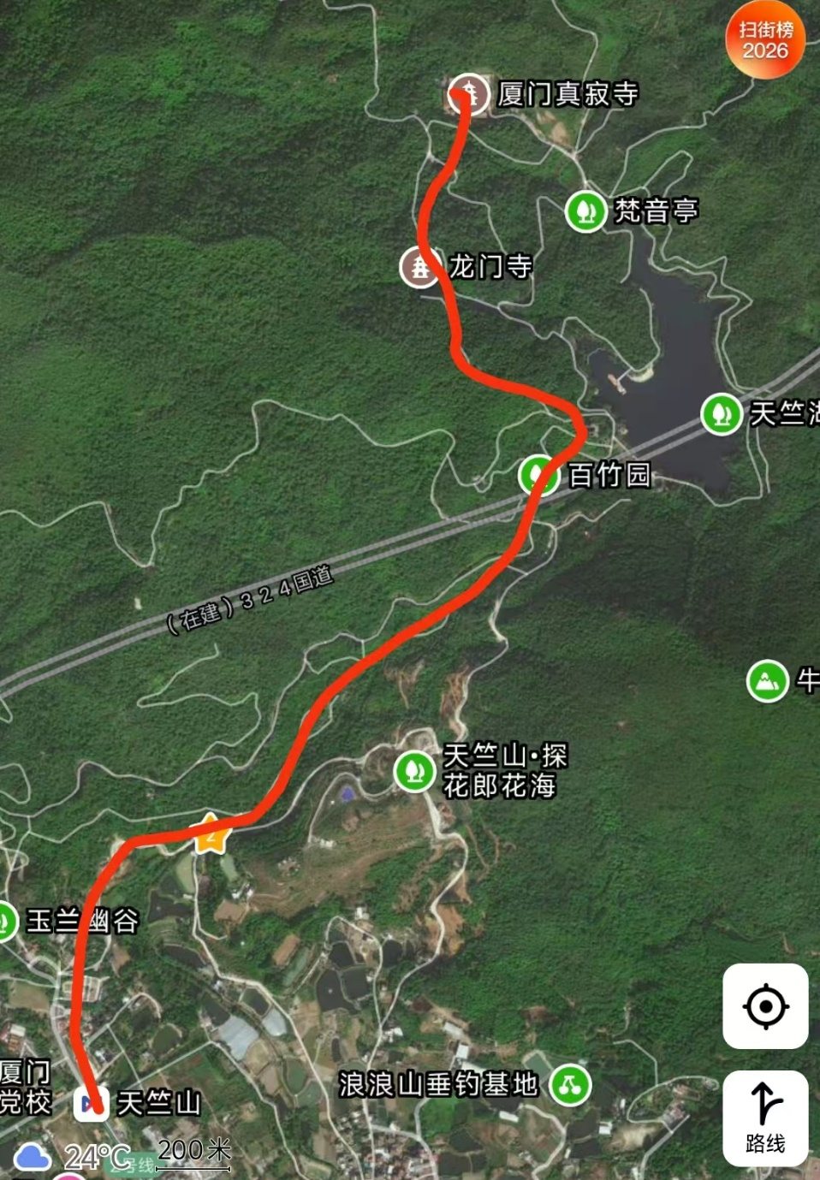
East Gate birding route
East Gate Route | East Gate — Bamboo Garden — Tianzhu Lake — Longmen Temple — Zhenji Temple: Follow the hillside footpath uphill from the East Gate, passing Bamboo Garden and Tianzhu Lake. You can continue to Forest Adventure and Longmen Temple, then head towards Zhenji Temple if you have the energy. The eastern route has a noticeable climb; allow 3–5 hours, or half a day if continuing to Zhenji Temple or beyond. Refreshments are available near Bamboo Garden.

Getting there: Take Metro Line 2 to Tianzhu Mountain Station, the metro station by the East Gate. There is no metro station at the West Gate; a park shuttle connects the two gates, but it starts relatively late. To begin birding early at the West Gate, drive or take a taxi. Park shuttles serve the east and west routes and can help on the return journey. West-side shuttle stops are at the West Gate and Huagu Yizhan (Flower Valley); east-side shuttle stops are at the East Gate, Bamboo Garden, Tianzhu Lake and Longmen Temple.

Difficulty: ★★★☆☆ (3/5)
The main challenges are the park's large size, tall forest and the need to locate birds by sound. Many forest birds remain hidden in the canopy or dense undergrowth; listen first, then search patiently. Stay on paved or gravel paths and watch your footing. Although some supplies are available in the park, bring water and snacks. For longer visits in spring and summer, insect repellent is essential.

Common residents: Huet's Fulvetta, Streak-breasted Scimitar Babbler, Fire-breasted Flowerpecker, Chestnut Bulbul, Mountain Bulbul, Black Bulbul, Grey Treepie, Black-naped Monarch, Crested Goshawk, Black Eagle, Slaty-backed Forktail, etc.

Summer visitors: Brown-breasted Flycatcher, Hainan Blue Flycatcher, Orange-headed Thrush, Square-tailed Drongo-Cuckoo, Large Hawk-Cuckoo, Asian Lesser Cuckoo, Hodgson's Hawk-Cuckoo, etc.

Passage migrants to look for: Fairy Pitta, Narcissus Flycatcher, Yellow-rumped Flycatcher, Ferruginous Flycatcher, Japanese Paradise Flycatcher, Green-backed Flycatcher, Eurasian Goshawk, Japanese Scops Owl, Siberian Blue Robin, etc.

Winter visitors: Red-flanked Bluetail, Pale Thrush, Eyebrowed Thrush, Japanese Thrush, Asian Stubtail, Rufous-tailed Robin, etc.

Notable records: Fairy Pitta, Red-legged Crake, Slaty-legged Crake, Large Cuckooshrike, Red-headed Trogon, Ryukyu Flycatcher, Eurasian Woodcock, etc.

Birding tip: The park is busy on weekends, so arrive early. The best birding is around sunrise to approximately 9 a.m.

- Haicang District · Maluan Bay
The wetlands of Maluan Bay are among Xiamen's richest areas for bird diversity and have the city's highest recorded species total, with more than 220 species. Many first records for Xiamen have come from here, and rare and uncommon passage migrants and winter visitors have been recorded here. It also supports Xiamen's largest population of Grey-headed Swamphen. In 2024, more than 30 Oriental Storks, a Class I nationally protected species, wintered here. Three places are particularly worth visiting: Bai Piti Tang (White Grebe Pond), Guoyun Stream and Yantang (Goose Pond).

Maluan Bay birding map
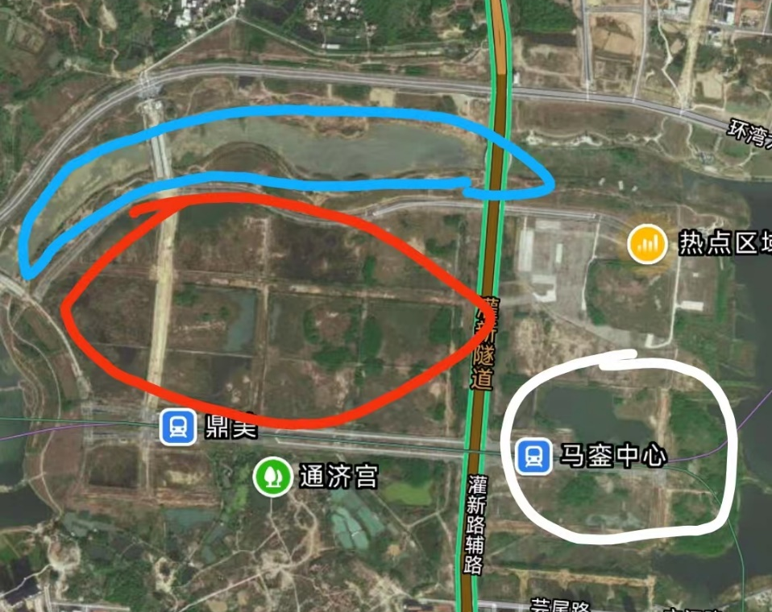
White indicates White Grebe Pond; red indicates Goose Pond; blue indicates Guoyun Stream.

Bai Piti Tang (White Grebe Pond):
Birdwatchers named this pond after a leucistic Little Grebe that returned to winter here several times. In winter, look for Northern Shoveler, Eurasian Wigeon and Great Crested Grebe, as well as Marsh Sandpiper, Pied Avocet and Spotted Redshank along the shallows. Flocks of starlings often pass over the nearby open ground and trees in autumn; Chinese Grey Shrike and Bluethroat have occasionally been recorded. Bewick's Swan has wintered here, and Bonelli's Eagle has also been recorded. On the open water farther out, large flocks of Great Cormorants can be seen in winter, along with ducks, gulls, Eurasian Coots, Great Crested Grebes and Black-necked Grebes. Check any gulls carefully: Pallas's Gull has been recorded here.
Guoyun Stream:
The shallow water beneath Neiwan Bridge is suitable for ducks and feeding shorebirds, including Temminck's Stint, Little Ringed Plover, Common Redshank and Long-toed Stint. Northern Lapwing, Ferruginous Duck and Western Water Rail have also been recorded nearby. Look up for Pale Sand Martins feeding in flight; Greater White-fronted Geese and Bean Geese sometimes fly overhead or rest nearby.
Yantang (Goose Pond):
Goose Pond is one of the richest wetlands for birds in Maluan Bay. Yellow Bitterns and Cinnamon Bitterns breed here in summer, Oriental Pratincoles are often seen overhead, and Watercocks may briefly emerge from the reeds. Grey-headed Swamphens are present year-round. In winter, the surrounding waters attract many waterbirds. Greater White-fronted and Bean Geese may feed here, while herons use the reeds and shallows; Purple Heron and Great Bittern may be concealed among the dense reeds, and Schrenck's Bittern can occur during migration. Bluethroats forage on the wetland ground, while Siberian Rubythroats and occasionally Common Chiffchaffs may be found in the shrubs. Check the reeds for Common Reed Bunting, Pallas's Reed Bunting and Chinese Penduline Tit. Raptors overhead may include Osprey, Eastern Marsh Harrier, Pied Harrier and Eastern Buzzard.

Getting there: Maluan Bay's wetlands cover a large area, making it tiring to visit all sites on foot. Driving makes it easier to move between them. By public transport, take Metro Line 2 or 6 to Maluan Center Station, then continue by taxi. Taxis are generally available in the surrounding area.
Suggested birding duration: Half a day to a full day. The three sites are far apart; visiting by car allows you to adjust your schedule according to bird activity.
Best months: November–March for wintering waterbirds. Look for passage migrants in spring and autumn, and breeding wetland birds in summer.
Difficulty: ★★★☆☆ (3/5)
The area is extensive, with tall grass and many insects. Wear long sleeves and trousers to reduce bites; driving is recommended between sites.
Common residents: Pied Kingfisher, Grey-headed Swamphen, Common Moorhen, Little Egret, Plain Prinia, Little Grebe, Black-winged Kite, Black Kite, Black-winged Stilt, etc.
Passage migrants: Cotton Pygmy Goose, Pheasant-tailed Jacana, Schrenck's Bittern, Blue-and-white Flycatcher, Japanese Paradise Flycatcher, Lanceolated Warbler, Pallas's Grasshopper Warbler, Northern Lapwing, Sharp-tailed Sandpiper, Temminck's Stint, etc.
Summer visitors: Little Tern, Oriental Pratincole, Cinnamon Bittern, Watercock, Yellow Bittern, etc.
Winter visitors: Great Bittern, Greater White-fronted Goose, Bean Goose, Eurasian Spoonbill, Black-faced Spoonbill, Common Reed Bunting, Pallas's Reed Bunting, Marsh Sandpiper, Eastern Marsh Harrier, Pied Harrier, Pale Sand Martin, Bluethroat, Siberian Rubythroat, Baillon's Crake, Purple Heron, Falcated Duck, Northern Shoveler, Eurasian Wigeon, Tufted Duck, Short-eared Owl, Common Kestrel, Chinese Penduline Tit, etc.
Notable records: Oriental Stork, Black Stork, Smew, Western Water Rail, Hen Harrier, Common Chiffchaff, Manchurian Reed Warbler, Bewick's Swan, Baikal Teal, Chinese Egret, Oriental Plover, Little Curlew, Relict Gull, Pallas's Gull, Amur Falcon, Daurian Starling, Chestnut-cheeked Starling, Rosy Pipit, Chinese Grey Shrike, etc.

Birding tip: There is much tall grass around the wetlands; wear long sleeves and trousers and protect yourself against insects. Watch from roads and public areas, keep your distance from birds, and do not enter the reeds or mudflats to pursue them.

7.Jimei District · Xinglin Bay
Xinglin Bay lies in central Jimei District. Its 6.9-square-kilometre water surface makes it Xiamen's largest urban freshwater lake. Xinglin Bay is home to the Xiamen Garden Expo Park and the Xinglin Bay National Urban Wetland Park, the city's only national urban wetland park. Xinglin Bay was also included in Fujian Province’s first list of Important Wetlands. The bay's extensive open water, reedbeds and series of habitat islands make it an important refuge and wintering site for migratory birds. The first Great Cormorants arrive around October, and numbers build through the winter. At the winter peak, 8,000 to more than 10,000 may be present across Xinglin Bay and the Garden Expo Park waters. Flocks fishing and circling above the bay are its signature birding spectacle. In winter, look for Tufted Duck, Greater Scaup, Eurasian Coot and Caspian Tern on the water. Black-browed Reed Warbler, Manchurian Reed Warbler and Chinese Penduline Tit can be found among the reeds in autumn and winter, while migration brings opportunities to see several species of grasshopper warbler.

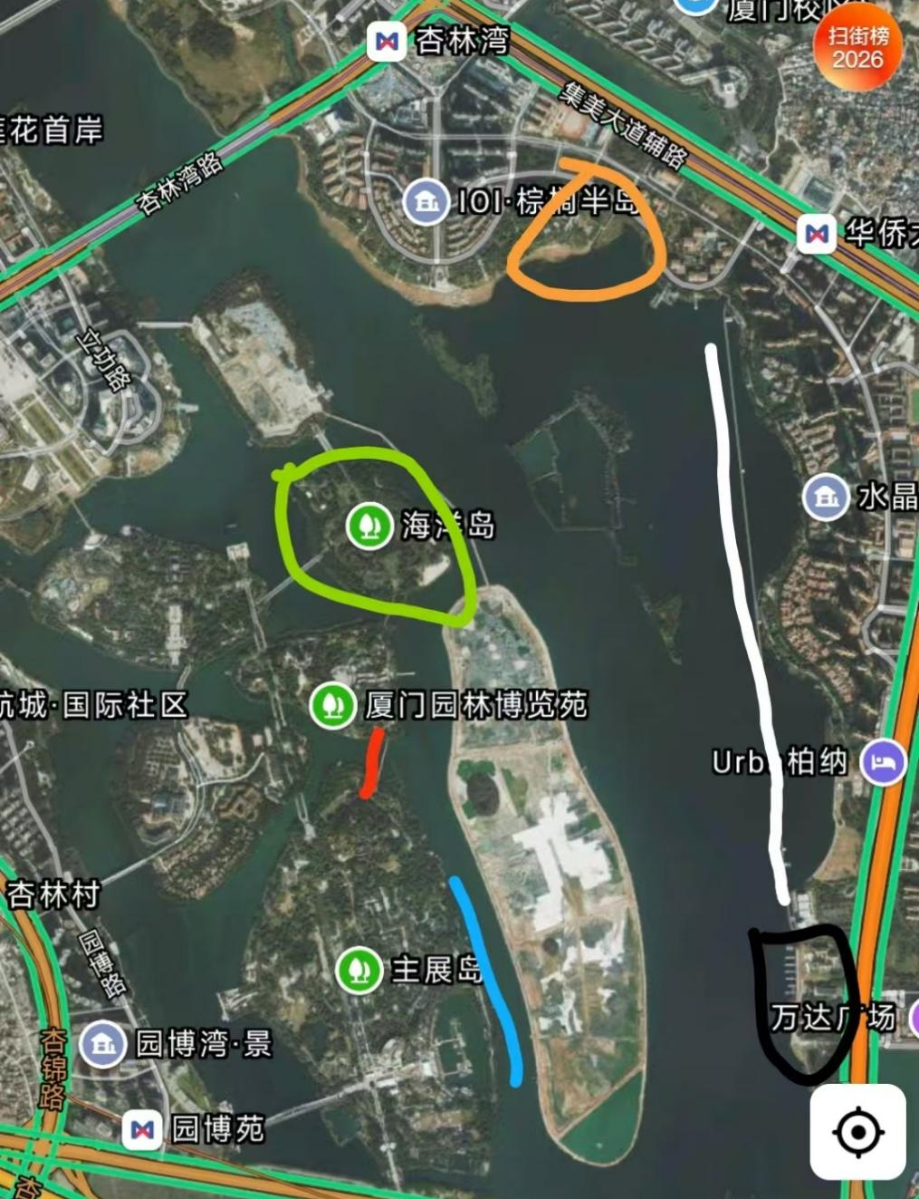
Suggested Xinglin Bay map markers: Blue — birdwatching walkway in the Garden Expo Park; red — Qianxiang Bridge in the park; green — Haiyang Island in the park; white — waterfront cycling path; black — Xiamen Water Sports Centre; orange — Water Show Square. Mark the points only; lines or shaded areas are not necessary.
Getting there — Garden Expo Park: Navigate to ‘Xiamen Garden Expo Park West Gate 1’. Take Metro Line 1 to Garden Expo Park (Yuanboyuan) Station, exit the metro station through Exit 2 and walk into the park. Drivers can use the Garden Expo Park car park.
Getting there — Water Sports Centre: Driving or taking a taxi is convenient. Navigate to ‘Xiamen Water Sports Centre’; parking is available nearby.
Suggested birding duration: About 2–3 hours.
Best months: November–March for wintering waterbirds. In spring and autumn, check the reeds for passage migrants.
Difficulty: ★★☆☆☆ (2/5)
Paths around Xinglin Bay are generally level, but the area is extensive and walking distances can be long. Near the Water Sports Centre, you can walk or cycle along the waterfront cycling path. When stopping to watch birds, make room for cyclists.

Common residents: Little Egret, Chinese Pond Heron, Black-crowned Night Heron, Eurasian Hoopoe, Chinese Blackbird, Sooty-headed Bulbul, Grey-headed Swamphen, Greater Coucal, etc.
Passage migrants to look for: Cinnamon Bittern, Whiskered Tern, Oriental Reed Warbler, Pallas's Grasshopper Warbler, Black-naped Oriole, Yellow-breasted Bunting, Manchurian Reed Warbler, etc.
Common summer visitors: Yellow Bittern, Asian Koel, Plaintive Cuckoo and Little Tern.
Common winter visitors: Great Cormorant, Tufted Duck, Eurasian Coot, Great Crested Grebe, Great Egret, Grey Heron, Caspian Tern, etc.
Notable records: Styan's Grasshopper Warbler, Black-faced Spoonbill, Chinese Egret, Pallas's Gull, Scarlet-backed Flowerpecker, Thick-billed Warbler, etc.
Birding tip:
Cormorants are especially active in the early morning and late afternoon. From the waterfront cycling path, watch flocks skim low over the water or line the distant treetops like a row of dark sentinels. The sight and the rush of wings overhead can be striking. Give the flocks space: do not chase or disturb them, and keep the waterside quiet.

Points to mark on the birding map: Water Show Square, waterfront cycling path, Water Sports Centre, Qianxiang Bridge, Haiyang Island and birdwatching walkway.

8.Tong’an District · Xiaoping Forest Park
Xiaoping Forest Park lies in Xiamen's northern mountains and forms part of Xiamen Lianhua National Forest Park. It covers approximately 16.66 square kilometres at elevations of 400–800 metres. Its relatively high elevation and mix of forest, tea gardens, streams and a reservoir make it one of Xiamen's best places for forest birds. Focus on the Xiaoping tea gardens and Xiaoping Reservoir. The tea gardens and nearby bamboo have records of Short-tailed Parrotbill, Spot-breasted Parrotbill, Russet Bush Warbler, Hodgson's Hawk-Cuckoo, Pygmy Cupwing and Hill Prinia; Mountain Hawk-Eagle and Bonelli's Eagle have also flown over the tea gardens. Along the streams, look for Slaty-backed Forktail and Plumbeous Water Redstart; Brown Crake has also been recorded. Around the reservoir, watch for breeding House Swifts and Asian House Martins. Both parrotbills and Barred Cuckoo-Dove have been recorded nearby.

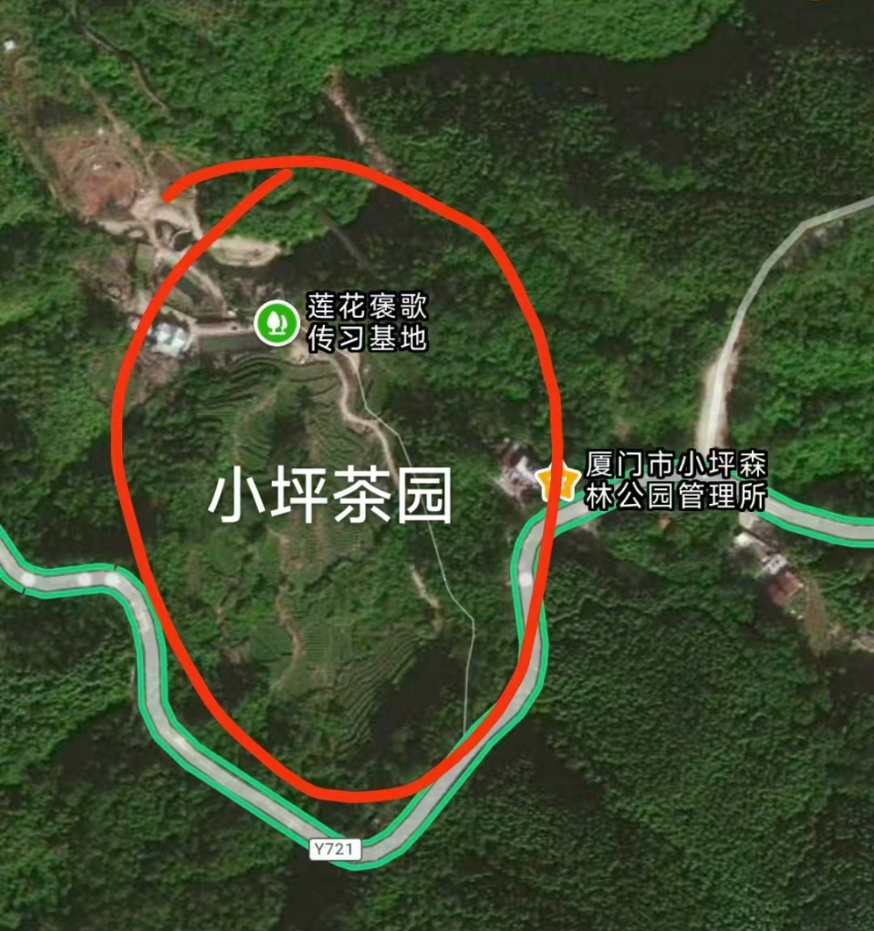

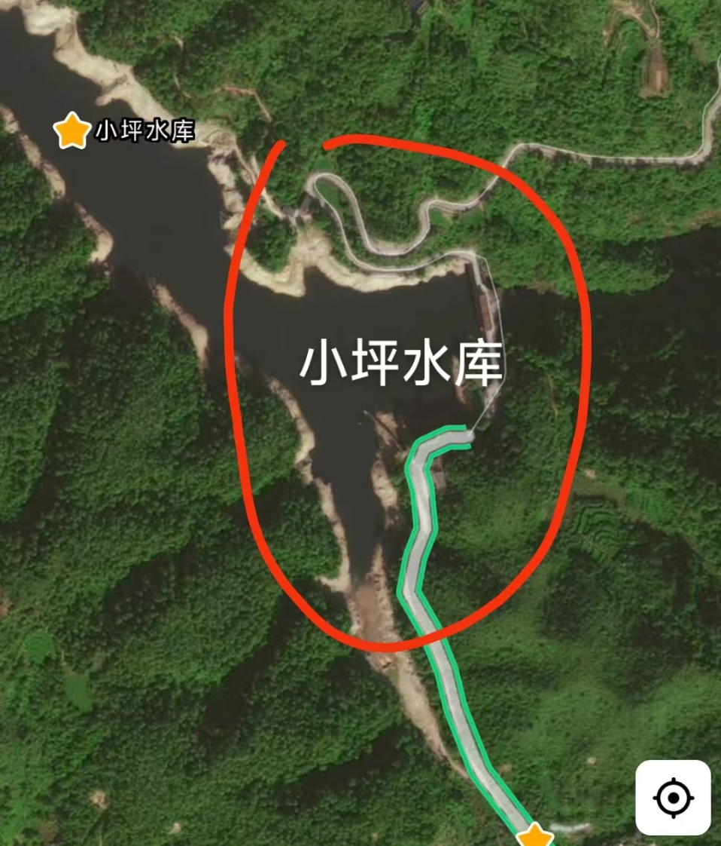

Getting there: Driving is recommended. The journey from Xiamen Island takes about 1–1.5 hours. The mountain approach includes about 10 kilometres of winding road with many sharp bends; drive slowly. Navigate separately to ‘Xiaoping Forest Park Bus Stop’ (near the tea gardens) and ‘Xiaoping Reservoir’. The two areas are some distance apart; drive between them and stop only where it is safe.
Suggested birding duration: About 3–4 hours; allow half a day for both areas.
Best months: February–April, when birds sing actively and are easier to locate. Winter is also suitable. Summer can be hot, so go early in the morning.
Difficulty: ★★★★☆ (4/5) The main challenges are getting there and finding birds, rather than a long hike. The trees are tall and the undergrowth dense, so recognising calls helps. Protect yourself against insects in spring and summer. Food and supplies are available near the Xiaoping Forest Park bus stop.
Common residents: Chinese Bamboo Partridge, Hill Prinia, Fire-breasted Flowerpecker, Rufous-faced Warbler, Streak-breasted Scimitar Babbler, Grey-sided Scimitar Babbler, Red-billed Leiothrix, Black Eagle, Crested Serpent Eagle, etc.
Summer visitors: Large Hawk-Cuckoo, Hodgson's Hawk-Cuckoo, Asian Lesser Cuckoo, etc.
Notable records: Slaty-legged Crake, Short-tailed Parrotbill, Hodgson's Hawk-Cuckoo, Spot-breasted Parrotbill, Spotted Elachura, Mountain Hawk-Eagle, Bonelli's Eagle, etc.
Birding tip: Drive slowly along the mountain road. At a safe place, stop to listen before getting out to search. Spend more time where birds are calling. Move gently near bamboo and shrubs; wear long sleeves and trousers and carry insect repellent in spring and summer.

Points to mark on the birding map: Xiaoping Forest Park Bus Stop, Xiaoping Reservoir and Xiaoping tea gardens.

9.Xiang'an District · Oucuo–Caicuo Coastal Mudflats
The coastal wetlands of eastern Xiang'an have extensive mudflats, tidal channels and shallow coastal waters, providing important resting and feeding habitat for Xiamen's coastal waterbirds. During migration and winter, many shorebirds gather here to feed. Chinese Egret, Nordmann's Greenshank, Black-faced Spoonbill and Saunders's Gull, all Class I nationally protected species, are regularly seen in the wider area. Nearby farmland and shelterbelts provide places for smaller migrant birds to rest and feed.
The mudflats around Caicuo, the tidal channels and Dadeng Island are among the viewing areas worth exploring. At low tide, shorebirds spread out across the mud and channels to feed. As the tide rises, they move closer to shore and eventually gather at nearby high-tide roosts. At times, large flocks take off together in spectacular waves. Choose a viewpoint based on the day's tide.
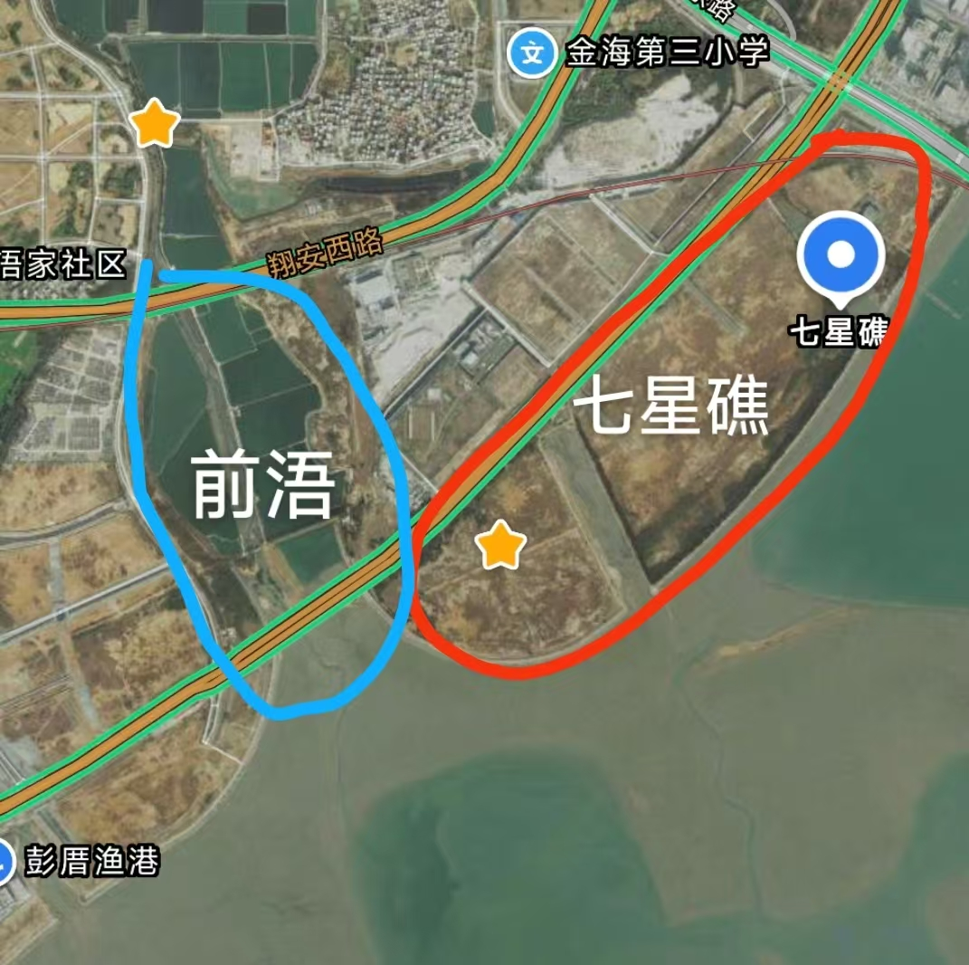
Getting there: The coastline is long and the sites are spread out; driving or taking a taxi is recommended.
Suggested birding duration: About 2–3 hours for one stretch of coast; allow half a day for several sites.
Best months: October–May. October–December and March–May are especially good for passage shorebirds; January–February is suitable for wintering waterbirds.
Best time of day: During daylight, as the tide rises towards high tide and around the high-tide peak. Arrive in advance to watch flocks move closer to shore; their positions vary between shoreline sections as the tide changes.
Difficulty: ★★★☆☆ (3/5) Some stretches require a long walk, the viewpoints are spread out, and visits need to be timed with the tide. Shorebirds are often distant and similar in appearance, so a spotting scope is recommended. Shade and supplies are limited along some stretches; bring water.
Residents: Little Egret, Chinese Pond Heron, Black-crowned Night Heron, White-throated Kingfisher, Oriental Skylark, Crested Myna, etc.
Passage migrants: Curlew Sandpiper, Red Knot, Black-tailed Godwit, Bar-tailed Godwit, Grey-tailed Tattler, Terek Sandpiper, Great Knot, Far Eastern Curlew, Ruddy Turnstone, Eurasian Oystercatcher, Whiskered Tern, White-winged Tern, etc.
Summer visitors: Little Tern and Black-naped Tern.
Winter visitors: Dunlin, Grey Plover, Pacific Golden Plover, Eurasian Curlew, Saunders's Gull, Caspian Tern, Red-necked Stint, etc.
Notable records: Chinese Egret, Nordmann's Greenshank, Black-faced Spoonbill, Spoon-billed Sandpiper, etc.
Birding tip: Check the tide before setting out. Watch the mudflats, tidal channels and distant flocks from public roads or viewing areas. Do not walk onto the mudflats to pursue birds, and take particular care along the shore on a rising tide.

